**

# **Tool Box Safety Talk # 21 Week Starting 05-19-2024.**

**Topic: Noise Exposure**

Exposure to high levels over 85 dB of noise can cause permanent hearing loss. Surgery or hearing aids cannot help in correcting this type of hearing loss. The construction industry generates many noisy operations and can be a significant source of noise exposure.

Damage to your hearing can be prevented, but once permanent noise-induced hearing loss occurs, it cannot be cured or reversed. Hearing loss usually occurs gradually, so you may not realize it is happening until it is too late. A one-time exposure to a sudden powerful noise, such as an explosion, may damage your hearing instantly. Prolonged exposures to loud noise can lead to a gradual, but permanent, loss of hearing.

The following list identifies the most common Hearing Protective Devices used in the construction industry to reduce noise exposure and conserve your hearing:

• Roll-down foam earplugs

• Reusable earplugs

• Custom molded earplugs

• Canal caps

• Earmuffs

**2-to-3 FOOT RULE**: Stand about an arm’s length away from your coworker: If you must raise your voice to be heard 2-3 feet away, you should assume that the sound level is at or above 85 dB.

OSHA's permissible exposure limit (PEL) is 90 dBA for all workers for an 8-hour day.

**3 STEPS TO NOISE CONTROL**:

1. Reduce it: Use the quietest equipment available.

2. Move it: Locate noisy equipment away from workers.

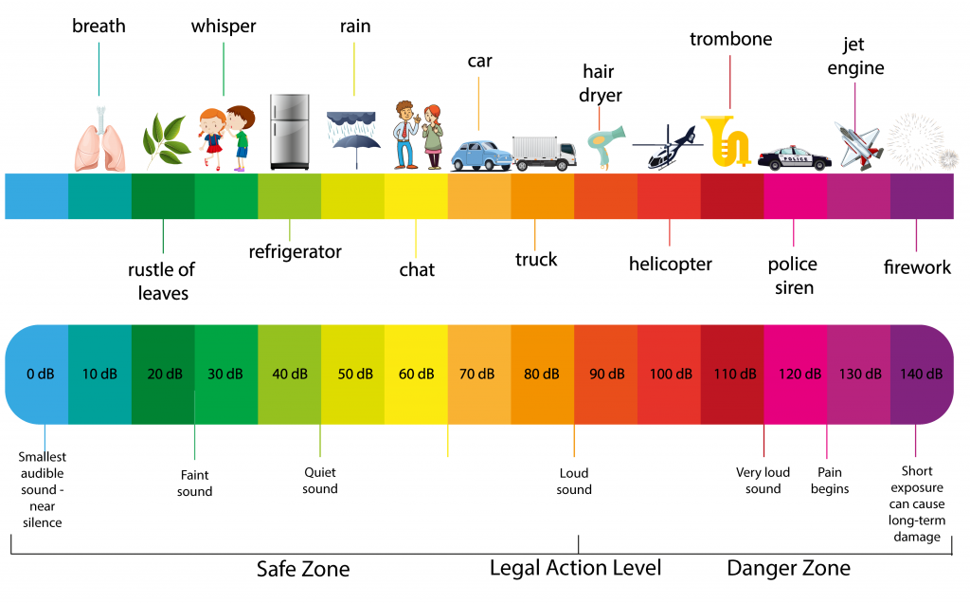3. Block it: Erect temporary barriers to block noise from reaching workers.

Safety Recommendations: _______________________________________________________________________

Job Specific Topics: _____________________________________________________________________________

S.D.S Reviewed: ________________________________________________________________________________

**TRAINING ROSTER**

COMPANY: ______________________ JOBSITE: _______________________

## SUPERVISOR: ____________________ DATE: _________________________

**# 21 Noise Exposure 05-19-2024.**

**ADDITIONAL TOPICS COVERED: _________________________________**

|  |  |
| --- | --- |
| **NAME (Please Print)** | **SIGNATURE** |
|  |  |
|  |  |
|  |  |
|  |  |
|  |  |
|  |  |
|  |  |
|  |  |
|  |  |
|  |  |
|  |  |
|  |  |
|  |  |
|  |  |
|  |  |